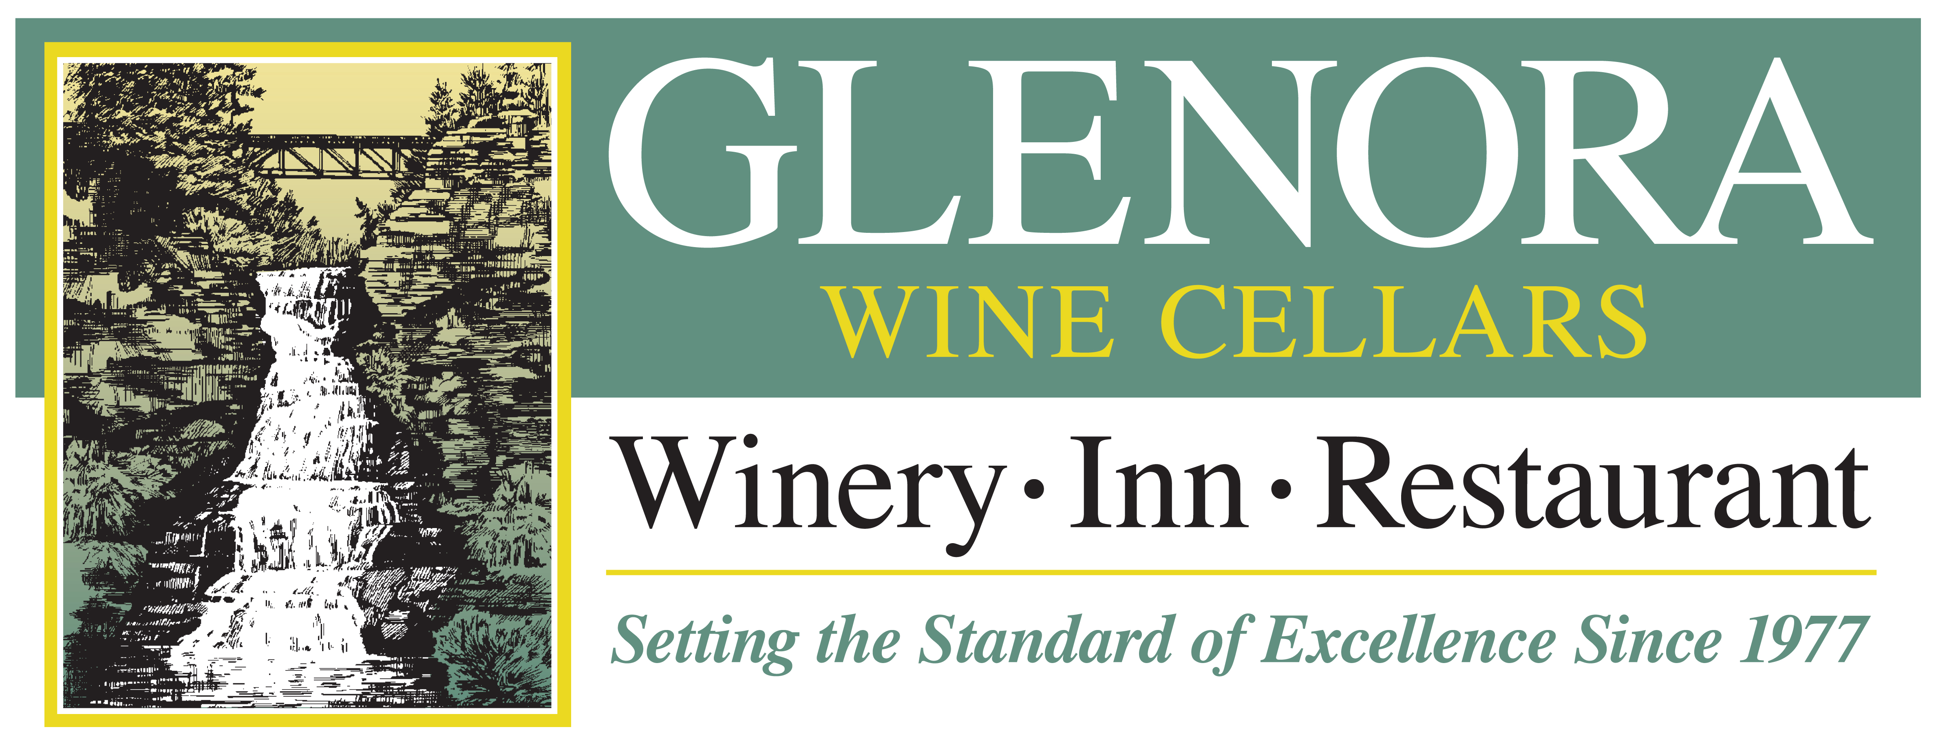

WINEMAKER’S NOTES

2023 Vidal Blanc
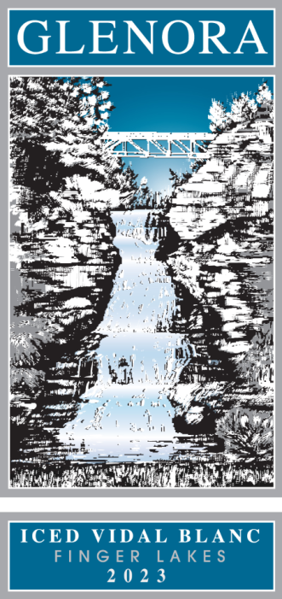
ICED WINE

TASTING NOTES

Our 2023 Iced wine shows tempting aromas of apricot, zesty mandarin, pineapple and biscotti. These concentrated aromas, a product of the grapes being pressed while frozen, continue and linger on the palate, supported by vibrant acidity that keeps the wine in balance with the high residual sugar for a truly decadent experience. Try with steamed lobster with drawn butter or enjoy with lemon curd or angel-food cake.

VINEYARD LOCATION
100% Glenora Farms West side of Seneca Lake

APPELLATION | Finger Lakes, NY
VARIETAL COMPOSITION | 100% Vidal Blanc
PRESS DATE | October 31st, 2023
BOTTLE DATE | February 27th, 2024
CASES PRODUCED | 238
BRIX AT HARVEST | 34.3 degrees

RESIDUAL SUGAR | 20.2% by weight
TOTAL ACIDITY | 11.55 g/L
ALCOHOL | 9.0%
PH | 3.16

FERMENTATION DATA
Yeasts: Laffort ST Blanc | Length: 32 days

WINERY HISTORY
The first winery on Seneca Lake and a pioneer of New York’s Finger Lakes wine region. Located just 8 miles north of Watkins Glen, New York, Glenora Wine Cellars is widely known for its warm hospitality and magnificent lakeside setting, and is also home to a 30 room Inn and a fine dining restaurant. Since 1977, Glenora Wine Cellars has received numerous national and international awards and has hosted thousands of visitors.

Glenora Wine Cellars | 5435 State Route 14, Dundee NY 14837 | 800/243-5513 | www.Glenora.com
Edward Miller | Winemaker | Edward@Glenora.com

