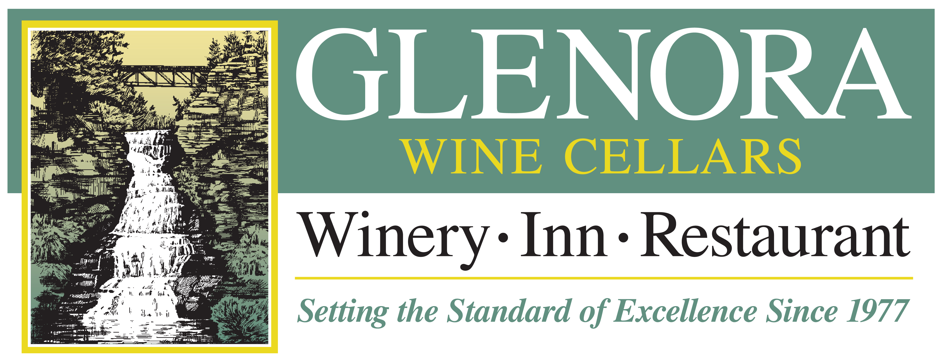

WINEMAKER’S NOTES

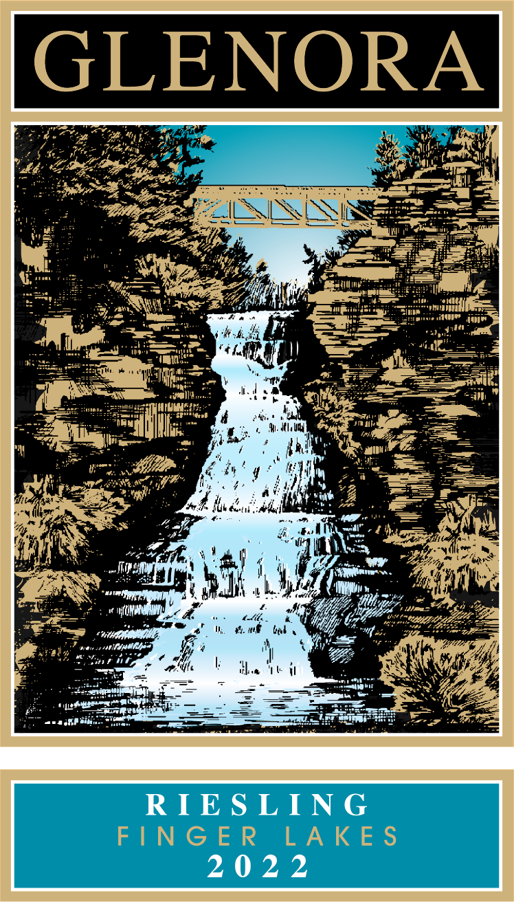
2022 Riesling

TASTING NOTES

Our 2022 Riesling offers engaging aromas of peach, apricot, white flower, as well as bursts of tropical fruit such as pineapple and guava. The palate shows firm acidity and reflects the nose with flavors of grapefruit marmalade and wildflower honey ending with a mouth-watering pithy finish. Enjoy with classic pairings such as spicy Asian cuisine or try with candied nuts or fruit cocktail.

VINEYARD LOCATIONS
74% Zugibe Vineyards, East side of Seneca Lake.
26% Glenora Farms, West side of Seneca Lake.
.

FERMENTATION DATA
Yeast: Epernay II, VIN 13, 58W3, Vin 2000
Temperature: 55⁰-60⁰ F
Length: 20-30 days

APPELLATION | Finger Lakes, NY
VARIETAL COMPOSITION | 100% Riesling
HARVEST DATES | Sept. 26th–October 5th, 2022

BOTTLE DATE: May 3rd, 2023

CASES PRODUCED | 900

RESIDUAL SUGAR | 2.3%
TOTAL ACIDITY | 6.97 g/L
ALCOHOL | 11.6%
PH | 2.96

WINERY HISTORY
The first winery on Seneca Lake and a pioneer of New York’s Finger Lakes wine region. Located just 8 miles north of Watkins Glen, New York, Glenora Wine Cellars is widely known for its warm hospitality and magnificent lakeside setting, and is also home to a 30 room Inn and a fine dining restaurant. Since 1977, Glenora Wine Cellars has received numerous national and international awards and has hosted thousands of visitors.

Glenora Wine Cellars | 5435 State Route 14, Dundee NY 14837 | 800/243-5513 | www.Glenora.com
Edward Miller | Winemaker | Edward@Glenora.com

