

WINEMAKER’S NOTES
2023 Gewürztraminer
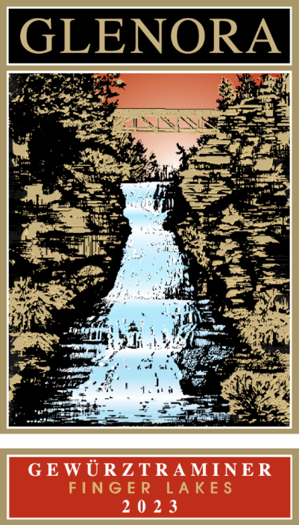

TASTING NOTES
Our 2023 Gewürztraminer has delicate lemon blossom, lychee, and tangerine aromas with hints of spice. The mild acidity is balanced by a moderate amount of residual sugar, giving the wine a rounder and more textured mouth-feel. This bright and flavorful wine is ideally suited to intense, savory dishes such as Asian or Caribbean cuisine.

VINEYARD LOCATIONS
100% Glenora Farms-West side of Seneca Lake

FERMENTATION DATA
Yeasts: Assmanhausen| Length: 26 days

APPELLATION | Finger Lakes, NY
VARIETAL COMPOSITION | 100% Gewürztraminer
HARVEST DATES | September 27th, 2023
BOTTLE DATE | February 28th, 2024
CASES PRODUCED | 333

RESIDUAL SUGAR | 1.0%
TOTAL ACIDITY | 6.56 g/L

ALCOHOL | 12.3%
PH | 3.45
WINERY HISTORY
The first winery on Seneca Lake and a pioneer of New York’s Finger Lakes wine region. Located just 8 miles north of Watkins Glen, New York, Glenora Wine Cellars is widely known for its warm hospitality and magnificent lakeside setting, and is also home to a 30 room Inn and a fine dining restaurant. Since 1977, Glenora Wine Cellars has received numerous national and international awards and has hosted thousands of visitors.

Glenora Wine Cellars | 5435 State Route 14, Dundee NY 14837 | 800/243-5513 | www.Glenora.com
Edward Miller | Winemaker | Edward@Glenora.com

